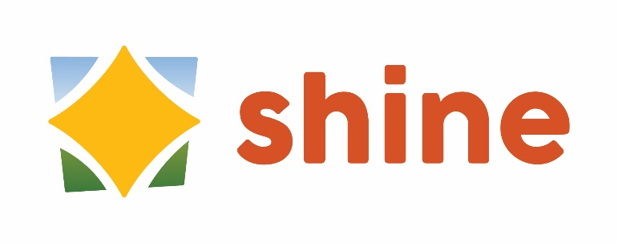
Regular Meeting Agenda
March 24, 10:30 a.m. to 11:30 a.m.

Blake Room, Somers Public Library

- Call to Order

- Welcome and Introductions

- Review and Approval of November 25 Meeting Minutes

- Adult Education Presentation by Arianna – “The More We Know: Spot the Signs, Start the Talk” – suicide prevention

- Partner Updates/Announcements

- Program Updates

- Adjournment

NEXT MEETING
April 28 – Kibbe Fuller Classroom, 619 Main St

Future Meetings
May 26
June 23
July – no meeting
August – no meeting
September 22
October 27
November 24
December – no meeting

